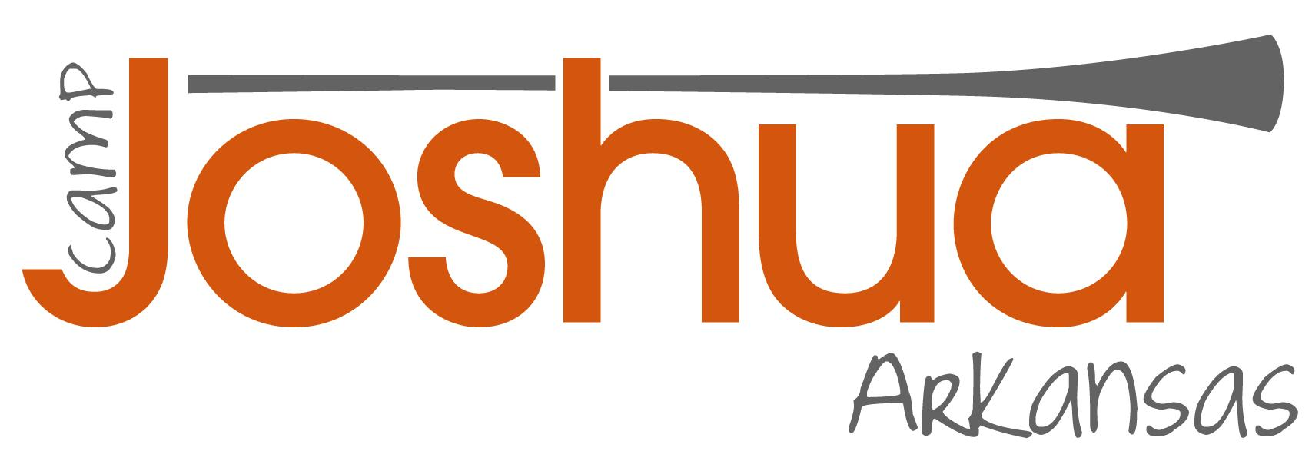

Arkansas Camp Joshua
July 26-28, 2024 Crossheirs Retreat Center in Humphrey, AR

Dear ACJ participant and Parents,

Arkansas Right to Life is so excited that you are coming to Camp Joshua! Get ready for an action packed and exciting weekend where you will learn to be a pro-life leader. Please read over the packing list carefully– bringing a snack to share and specific outfit requirements for the trip to the Capitol are included on it, and past students have overlooked them!

In this packet, you will find:

• Registration Form (mail back)

• Release Form (mail back)

• Transportation Waiver (mail back)

• Information Forms (YOU KEEP THESE)

Please make checks payable to Arkansas Right to Life and mail with signed forms to:

Limited Scholarships are available --- please let us know if you need one to attend.

Arkansas Right to Life | PO Box 1697, Little Rock, AR 72203

Remember, you can register online at www.campjoshuaar.org

Registration Form

Name_______________________________________________________________________

Address:_____________________________________________________________________

City:________________________________________________ State:__________

Zip: __________________

Telephone: H ( )______________________ C ( )__________________

Email Address:___________________________________________________________

Age:__________ Gender: M / F

Name of High School:__________________________________

Year in School: Freshman | Sophomore | Junior | Senior

Do you have specific dietary needs (vegan, vegetarian, etc)?________________________

My T-shirt size is: S | M | L | XL (circle one)

I’m getting to Camp Joshua by (circle one):

Riding the Bus Providing my Own Ride* Following in my Vehicle*

*Must be approved by Rose Mimms

If possible, I would like to room with:_______________________________________________

Parent(s)’ Name(s)_____________________________________________________________

How did you hear about Camp Joshua?____________________________________________

• Cost: $100.00 (includes meals, accommodations, materials, and T-Shirt)

• Make checks payable to Arkansas Right to Life and mail with signed form to:
Arkansas Right to Life | PO Box 1697 | Little Rock, AR 72203
Limited Scholarships are available --- please let us know if you need one to attend.

Registration Deadline: July15th, 2024 (Contact us to apply after this date)

Release Form

While I understand that Arkansas Right to Life (hereafter referred to as sponsors) will take reasonable steps to provide individual care and safety for my child, I am aware that the above mentioned organization, and their employees or agents cannot assume any responsibility for any injury, damage, or harm which might result during the course of participation in any activity connected to the Arkansas Camp Joshua.

In consideration of permitting my child to participate, I agree that such responsibility will remain with me, as the parent or guardian of my child. Should any claim be asserted by any person, as a result of the acts of my child while participating in the activity described above, or traveling to, from or part of such activity, or should my child or children assert any claim against “the sponsors”, its employees, agents, or member, I agree to indemnify and hold “the sponsors”, its employees, members, or agents harmless from any such claim, including attorney fees and costs incurred in defense thereof.

I further authorize medical treatment of my child or children, in the event of illness or injury sustained in my absence while my child or children participate in the sponsors’ Arkansas Camp Joshua.

Child’s Name_______________________________________________________________________

Parent’s Signature__________________________________________________________________

Date: ___________________

Parent’s Printed Name:_____________________________________________________________

*** If you (the attendee) are 18 years or older, please sign the above form inserting your name in both the parent/guardian and child blanks.

Mail to: Arkansas Right to Life | PO Box 1697, Little Rock, AR 72203

Information Form
(You keep this)

What to know about Arkansas Camp Joshua (ACJ), Transportation, and the Schedule:

Arkansas Camp Joshua is open to all religious denominations and is not affiliated with any particular religious group.

Students will be transported to Cross Heirs Retreat Center by charter bus. All students and leaders must complete a transportation waiver. This form should be included with registration and be signed by a parent or guardian if the student is a minor.

Private transportation is discouraged and must receive approval in advance.

Check-in for Camp Joshua is from 3:00-3:30 p.m. on Friday, July 26th at the Commuter Lot on Shackelford (753 Shackelford Rd.) in Little Rock. Departure will be at 3:30 p.m. sharp.

ACJ is run on a tight schedule, so please arrive no later than 3:30 pm.
Drivers may leave their vehicle on the Arkansas Right to Life parking lot over the weekend at their own risk. If a student chooses to do this, Arkansas Right to Life is not responsible for damaged or stolen vehicles or property.

Any parent who chooses to drive their child directly to CrossHeirs Retreat Center will need to arrive no later than 6:00 PM. They must inform AR Right to Life Director, Rose Mimms, of the fact that they will be traveling directly to Cross Heirs and will not be riding with the other students. The address for CrossHeirs is 140 Pintail Lane, Humphrey, AR 72073. If you need directions, you can get them at google.com/maps. If you have difficulty with directions, call Rose using the contact info below.

Pro-life students will assist with the weekend, but adult chaperones will be present at all times. On Sunday, July 28, parents are welcome to attend the tour and Legislative session at the State Capitol at 2 p.m. and /or arrive at 3 p.m. for the closing program and installation ceremony in the Old Supreme Court room on the 2nd floor. All students must be picked up by a parent or guardian by 4 p.m.

Information Form (continued)
(You keep this)
What to Bring:
• Toiletries & personal needs (Bedding and towels provided)
• Pen/Pencil and Notebook & Open mind ready to learn
• Respectful casual clothing (girls’ skirts and shorts no shorter than fingertip length, no revealing tops or tanks, appropriate sleepwear, must have undergarments)
- Clothing for messy, outdoor games
• One “dressy casual” outfit for Sunday afternoon at the Capitol (t-shirt
provided to wear for outing, so only “bottom” of outfit needed)
Boys: Church/Khaki Pants (no jeans) Girls: Skirt or Khaki/Black Pants (no jeans)
• Acoustic musical instruments (no loud music in bedrooms though)
• A snack food to share (a box of Little Debbies, granola bars, or fruit snacks would work great)
• Insect Repellent (Mosquitoes are not scarce at Cross Heirs, it is a hunting lodge near the woods)

What NOT to Bring:
• Cell phones will be put away for all speaker sessions
• No drugs, weapons, alcohol, or cigarettes or E-cigs
• A negative attitude

Where will Camp Joshua be held?
ACJ will be held at CrossHeirs Retreat Center in Humphrey (about an hour and fifteen minutes from Little Rock), with the only exception being a trip to the Capitol on Sunday afternoon.

Cross Heirs Retreat Center
Matt Mosler, Director
140 Pintail Lane
Humphrey, AR 72073
CrossHeirs Retreat Center www.crossheirs.org
www.facebook.com/crossheirs

Sponsor/Chaperone information & cell phone numbers:
  - Rose Mimms, Executive Director Arkansas Right to Life (501) 920-2276
  - Skylar Harper, Camp Joshua Coordinator (501 315-8244

Registration and other information also available online at www.CampJoshuaAR.org

Waiver and Permission to Transport Child
Arkansas Right to Life – Camp Joshua

Student Name (please print)__________________________________________________
Event: Camp Joshua - Arkansas Date: July 26-28,2024
Location: CrossHeirs Retreat Center, 140 Pintail Lane, Humphrey, AR 72023
Driver: Driver will be a licensed CDL adult employed by AR Destinations (over the age of 21 who is approved by ARTL).

I agree to be transported in a motor vehicle driven by an adult over age 21 to Camp Joshua Arkansas at CrossHeirs Retreat Center located at 140 Pintail Lane, Humphrey, AR 72023, on July 26, 2024, and to the Arkansas State Capitol on July 28, 2024 I understand that I am expected to follow all applicable laws regarding riding in a motor vehicle and expected to follow the directions provided by the driver and/or other adult volunteers. I have read and understand that:
- I will be traveling in a motor vehicle driven by an adult and will wear a safety-belt while traveling;
- I am expected to respect others, the vehicles they ride in, and the people I travel with during the trip;
- Riding in a motor vehicle may result in personal injuries or death from wrecks, collisions or acts by riders, other drivers, or objects; and
- I will remain in my seat and not be disruptive to the driver of the vehicle.

I recognize that by participating in this activity, as with any activity involving motor vehicle transportation, that I may risk personal injury or permanent loss. I hereby attest and verify that I have been advised of the potential risks, that I have full knowledge of the risks involved in this activity, and that I assume any expenses that may be incurred in the event of an accident, illness, or other incapacity, regardless of whether I have authorized such expenses.

As a condition for the transportation received, I further agree to release and forever discharge Arkansas Right to Life, its employees, president, board, and volunteers, from any claim that I might have myself or that could be brought on my behalf with regard to any damages, demands, or actions whatsoever, including those based on negligence, in any manner arising out of this transportation. I have read this entire waiver and permission form, fully understand it, and agree to be legally bound by its terms.

If under 18 must be signed by parent or guardian.

Name (please print): _________________________________________
Signature: ____________________________________________
Date: ___________________________

